CHAPTER II: LITERATURE REVIEW

Introduction
This chapter presents numerous kinds of literature on Image-based student Identification and classification using face Recognition. This literature was collected from different books, papers, articles, and studies related to the issue at hand. Specifically, the literature will concentrate on the identification methodologies, classification.

Biometric identification
Measuring and examining each person's distinct physical or behavioral traits is the aim of biometric systems. The use of physical components with distinguishing qualities is the primary characteristic of biometric systems. Both physiological (fingerprint, iris, palm print, face, etc.) and behavioral (signature, walking, speech patterns, facial dynamics, etc.) biometric systems have been described in the literature. According to Taskiran et al. (2020), facial biometrics has emerged as a highly favored biometric data collection method due to its ability to capture biometric data without requiring the user's agreement or invading their personal space.

Types of Biometric identification
Biometric systems are required for person identification and verification systems due to the growing importance of human elements in next generation technology. Certain biometric systems rely on physiological properties that are static, like:
- Face Recognition
- iris
- fingerprint
- hand geometry
- voice Recognition
as well as systems that make use of behavioral traits, sometimes referred to as soft biometrics, like the signature, gait, walking rhythm, speech pattern, and facial dynamics(Taskiran et al., 2020).

Face Recognition
One of the primary biometric characteristics has been the face, which finds use in a wide range of fields such as education, marketing, finance, entertainment, security and law enforcement, and human-computer interaction. The primary application domains and their respective subdomains are enumerated. The identity, age, gender, race, and facial expressions that convey emotions and mental states are all revealed by a person's face. Engineering, psychology, and neurology are all involved in the multidisciplinary field of studying the human face and facial behavior. Face recognition differs from a number of other biometric features in that
is especially appropriate for surveillance applications since it can be carried out in an unobtrusive manner and does not always require the subject's cooperation. Furthermore, face recognition is appropriate for behavioral biometrics since it can be based on both the face's dynamic and physical (static) properties. Face identification in unconstrained contexts is a difficult challenge because of differences in head attitude, illumination, age, and facial expression. Additionally, changes in look could result from facial hair, makeup, or accessories like scarves or glasses. Similarity between people (such as twins or cousins) makes facial recognition much more challenging (Taskiran et al., 2020).

Overview of face recognition
One of the most significant uses of biometrics-based authentication systems in recent decades is face recognition. Face recognition is a type of task pattern that involves classifying a face as known or unknown based on a comparison with photos of known individuals that are kept in a database. Face recognition is difficult because of the specific
variability in information because of random variation across ifferent people, including systematic variations from various factors such as lightening conditions and pose(Barnouti et al., 2016).
A facial recognition technique is an application of a computer for automatically identifying or verifying either an individual from a digital picture or a frame from a video source. The most organic method of biometric identification is this one. Facial recognition technologies have recently developed into two areas and they are Facial metrics and Eigen's faces. Facial metric technology relies on the manufacture of specific facial features (the system usually looks for the positioning of eyes, nose, and mouth and the distances between these features). The region of the face is resized to a predetermined, set size (e.g., 150–100 points). The term "canonical image" refers to this image of a standardized face. Following that, a face template contains the computed and stored facial metrics. The typical size of such a template is between 3 and 5 KB, but there exist systems with the size of the template as small as 96 bytes(Bhattacharyya et al., 2009).
Figure 12.1 Face

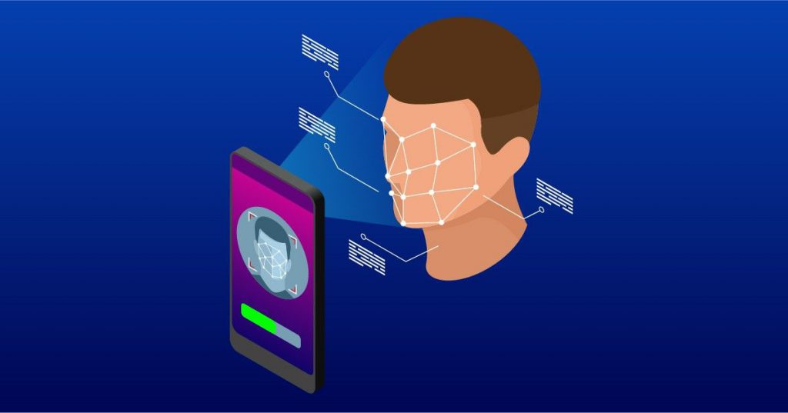

Taxonomy of face recognition
The two primary categories of face recognition systems seen in the literature are image-based and video-based techniques. Image-based systems use a person's physical characteristics to attempt to identify them. However, physical appearance as well as variations in appearance over time or facial dynamics are used by video-based systems. The general taxonomy of the literature on face recognition(Taskiran et al., 2020).
Three primary categories can be used to group image-based facial recognition (FR) techniques: i) appearance-based (or holistic) techniques, ii) model-based techniques, and iii) texture (local appearance) based techniques.
FACE DETECTION - The computer vision system tool box present in the MATLAB is very helpful for detecting faces from the CCTV footage .The computer vision tool box provides the object detection process and gives a custom detector. The people’s face can be easily recognized by using the people detector. Some of the histogram based classifiers are following Histogram of oriented gradients (HOG) features and a trained support vector machine (SVM) classifier. The output of the face detection method is always a cropped face image (Celine & others, 2019).
To classify the faces, a graph (i.e., kernel) It can also be used. It is the natural model of the relationship between faces. The nodes in this model stand in for faces. The potential interactions between nodes are represented by the edges. Then, machine learning methods such as support vector machine , kernel ridge regression , artificial neural networks or the graph-based semi-supervised learning methods can be applied to this graph to classify or to recognize the faces. Supervised learning techniques include kernel ridge regression, support vector machines, and artificial neural networks. The graph-based semi-supervised learning methods are the semi-supervised learning methods. Please note that the kernel ridge regression method is the simplest form of the support vector machine method(Tran et al., 2020).
Video-based face recognition methods can be classified into two main groups: i) Set-based methods and ii) Sequence-based methods. Set based methods treat the frames of a video sequence as a collection of images, without paying attention to the temporal order of the frames. On the other hand, sequence-based methods use the frames by keeping their temporal order. Hence, the dynamics of the face over time also plays a role in the recognition of the person It is very difficult to give a clear-cut taxonomy of all the work on face recognition in the literature. Hence, the proposed taxonomy in Fig. 1 is a coarse grouping of the methods in the literature and the algorithms in some groups may have overlapping properties(Taskiran et al., 2020).

Figure 22.2 face recognition

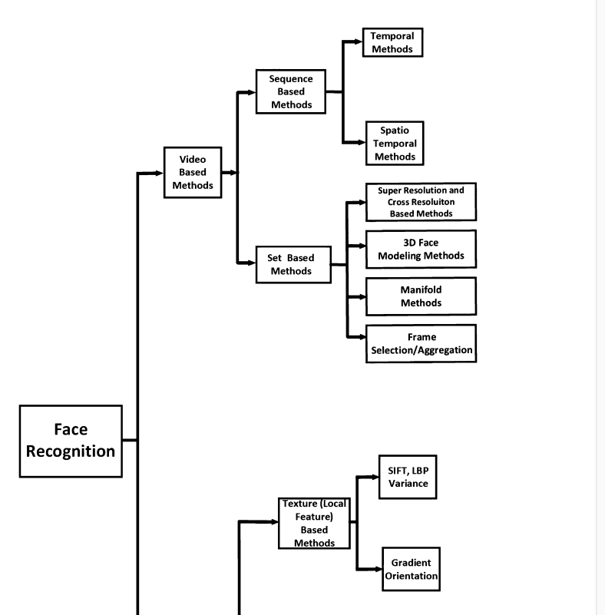

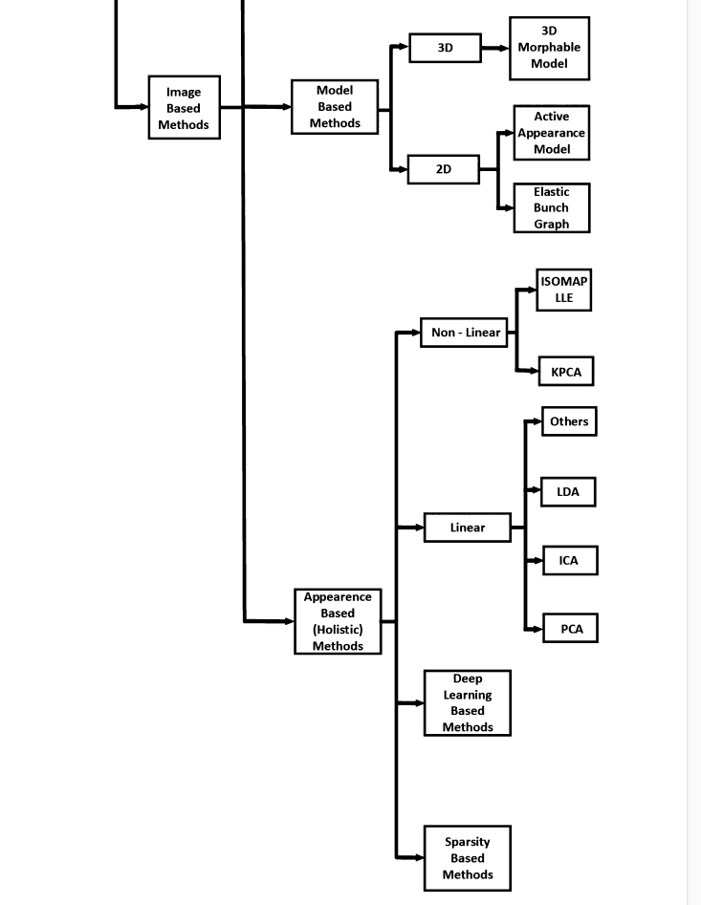

Main steps of face recognition
Face recognition can be viewed as either a verification or identification challenge. i) The face is captured in an input image or video.
ii) Face anti-spooﬁng module ensures the security of the system by employing presentation or adversarial attack detection (via liveness tests etc.).
iii)A face or facial landmark is identified in every frame of the video or image.
iv) Pre-processing is the process of applying several techniques to an image or video, such as alignment, noise reduction, contrast enhancement, or video frame selection.v) Extraction of facial features from a picture or video. While video-based methods utilize set-based or sequence-based feature extraction techniques, image-based methods use holistic, model-based, or texture-based techniques.
vi) Face identiﬁcation or veriﬁcation is performed.

Figure 32.3 steps of Face Recognition

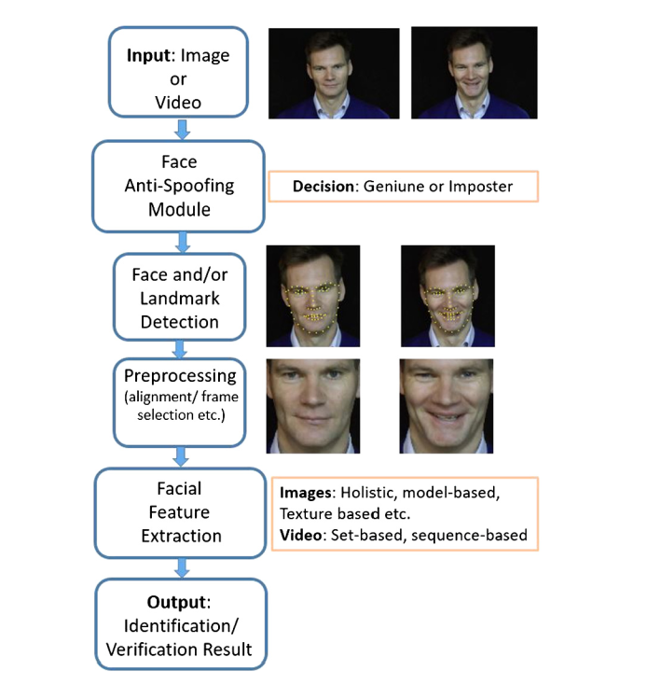

Iris recognition
Face This recognition method uses the iris of the eye which is a colored area that surrounds the pupil. Iris patterns are unique and are obtained through a video-based image acquisition system. Every iris structure has an intricate pattern. A combination of distinct features called the corona, crypts, filaments, freckles, pits, furrows, striations, and rings may be present. the iris pattern is taken by a special gray scale camera at a distance of 10- 40 cm of camera. Once the gray scale image of the eye is obtained then the software tries to locate the iris within the image. If an iris is found then the software creates a net of curves covering the iris. The software generates the iris code based on the point-to-line darkness. Two influences need to be considered in this situation. First, the overall darkness of the image is influenced by the lighting condition so the darkness threshold used to decide whether a given point is dark or bright cannot be static, it must be dynamically computed according to the overall picture darkness. Secondly, the size of the iris changes as the size of the pupil changes. Before computing the iris code, a proper transformation must be done (Bhattacharyya et al., 2009).

Figure 42.4 Iris
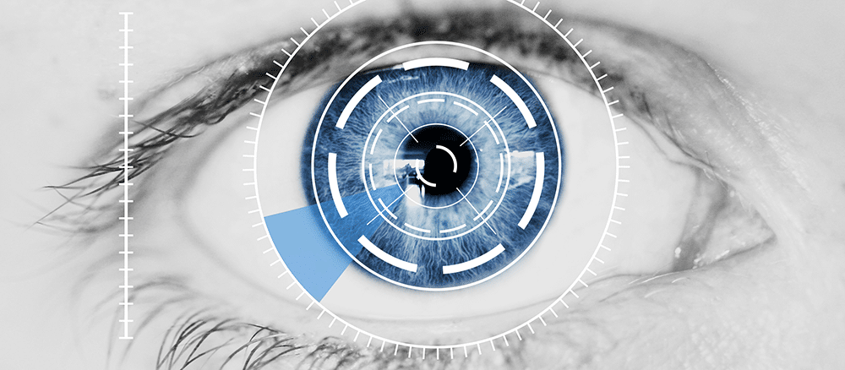

Fingerprints
Fingerprints are widely used in the personal identification system. In the era of information technology, fingerprint identification is popular and widely used worldwide, not only for anti-criminal but also as a key technique to deal with personal affairs and information security (Yang & Nanni, 2011).Any or all of the finger's friction ridges can leave an impression on a fingerprint. A elevated area of the palmar (palm), digit (fingers and toes), or plantar (sole) skin made up of one or more interconnected ridge units of friction ridge skin is called a friction ridge. Occasionally, these ridges are referred to as "dermal ridges" or "dermal." The traditional method uses ink to get the fingerprint onto a piece of paper. After that, a conventional scanner is used to scan this piece of paper. Now in the modern approach, live fingerprint readers are used. These are founded on principles related to optics, heat, silicon, or ultrasonics. It is the oldest of all biometric techniques. An optical fingerprint reader is the most common at present. They are based on reflection changes at the spots where finger papilar lines touch the reader's surface. All the optical fingerprint readers comprise the source of light, the light sensor, and a special reflection surface that changes the reflection according to the pressure (Bhattacharyya et al., 2009).

Figure 52.5 Fingerprint

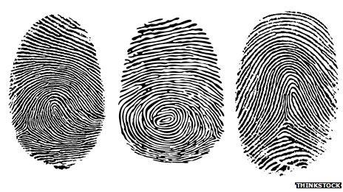

Hand geometry
Face Hand geometry has emerged as one of the most widely used biometric access control technologies in recent years, accounting for about half of the physical access control industry. Some features related to a human hand, e.g., length of fingers, are relatively invariant and peculiar (although, not unique) to each individual. The subject must cooperate with the image acquisition equipment in order to take frontal and side view pictures of their palms spread outward on a panel. The registration of the palm is accomplished by requiring the subject's fingers to be aligned with a system of pegs on the panel which is not convenient for subjects with limited flexibility of palm (Jain et al., 2006). It is based on the fact that nearly every person’s hand is shaped differently and that the shape of a person’s hand does not change after a certain age. These methods involve estimating the hand's surface area, thickness, width, and length. Various methods are used to measure the hands- Mechanical or optical principle There are two sub-categories of optical scanners. Devices from the first category create a black and white bitmap image of the hand’s shape. This is easily done using a source of light and a black and white camera. The bitmap image is processed by computer software (Bhattacharyya et al., 2009).

Figure 62.6 Hand recognition

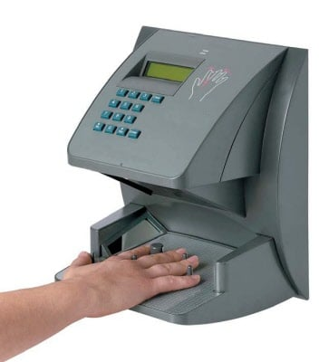

Voice Recognition
Face Voice is also a physiological trait because every person has a different pitch, but voice recognition is mostly focused on the analysis of a person's speech pattern, which is categorized as behavioral. The vocal traits that generate speech are the main emphasis of speaker verification, not the speech's actual sound or pronunciation. The dimensions of the vocal tract, mouth, nasal cavities, and other speech processing mechanisms in the human body affect the vocal features. It doesn’t require any special and expensive hardware (Bhattacharyya et al., 2009).

As reported by (Subha, 2017),Voice or speech recognition is the capacity of a machine or program to understand and execute spoken orders, or to take in and interpret dictation. Although each person has a unique pitch, voice recognition is primarily dependent on behavioral analysis of speech patterns, which makes voice recognition a physiological attribute as well.

Image Classification
An important area of study for artificial vision systems that has attracted a lot of attention recently is picture classification. The purpose of this field is to categorize an input image according to its visual content. At the moment, the majority of individuals used manually created features to give an image a specific description. The final conclusion was then reached by applying learnable classifiers, like random forests and decision trees, to the extracted features.The problem arises when large numbers of photos are concerned(Singh & Singh, 2020).

  - CCTV Camera

Closed-circuit television (CCTV) and body-worn video cameras (BWVCs) have rapidly spread throughout policing. The significance of determining optimal procedures for these two technologies has increased due to their extensive implementation. The research community has worked toward the identification of such best practices, with bodies of knowledge emerging for both CCTV and BWVCs over recent decades. Given its earlier emergence, research on CCTV is more developed(Piza, 2021).

There has been extensive There is a dearth of studies on the investigative utility of closed-circuit television (CCTV), but plenty on its effectiveness in preventing crime. In order to determine how frequently and how conditions affect the usefulness of CCTV evidence, this study analyzed 251,195 offenses that the British Transport Police had reported as having occurred on the British railway network between 2011 and 2015.Investigators had access to CCTV in 45% of cases, and in 29% of those cases (or 65% of those when it was available), it was deemed to be beneficial. Effective CCTV was linked to noticeably higher odds of crimes being solved for every category of crime, with the exception of fraud and the presence of narcotics or weapons. Serious crimes were more likely to have available images, but incidents that happened at odd hours or in particular kinds of places were less likely to have images. CCTV seems to be an effective investigative tool for many different kinds of crime, despite the fact that this research was restricted to offenses on railroads. The amount of public spaces that CCTV cannot cover is one of the main problems limiting its usefulness. There are some suggestions made for improving the use of CCTV (Ashby, 2017).

  - Image enhancement

One of the most crucial aspects of digital image processing is image enhancement. It is among the trickiest and most significant tasks in the processing of digital images. Techniques for image enhancement are applied to raise an image's visual quality. Nowadays, the majority of applications, including radiography, MRI, nuclear medicine, ultrasound imaging, tomography, cardiography, fundus imaging, and so on, use medical imaging. The two main issues with medical images are contrast and image quality. Image enhancement clarifies the image for computer analysis or human viewing. While image augmentation doesn't increase the data's inherent information content, it might highlight the features of interest to detect the objects in a simple and efficient manner(Vasuki et al., 2017).
Image enhancement is a powerful tool which is widely used in computer vision. It is a popular sub-specialization of image processing. Image enhancement is the improvement of image quality to a better and more understandable level for visual appearance for future automated image processing, such as analysis, detection, segmentation and recognition. Improving interpretability or perception of data in images can be thought as main goal of image enhancement process so that human viewers or future automated image processing can benefit from the new enhanced image. When dealing with image enhancement it must be kept in mind that image enhancement implementation doesn't have effect upon the intrinsic information content of the data. What is effect is to increase the dynamic range of the intensity values of image. Over the years a variety of image enhancement methods have been proposed with the developments in image processing field. These methods have been independently studied for several different applications, resulting in a large body of research. Although there is a wide range of methodologies, classification and comparison of techniques become difficult because each technique is often designed for specific applications and not necessarily for specific types of problems or data. However the approaches differ in information on which enhancement relies. Briefly stated, the researchers or scientists who intend to enhance images should establish the connection between the changes in the images/targets of enhancement and the type of enhancement methods which can most appropriately be applied.(Irmak & Ertas, 2016).

Image enhancement is basically improving the Interpretability or perception of information in images for human viewers and providing better input for other automated image processing techniques [1]. There exist many techniques that can enhance a digital image without spoiling it. The enhancement methods can broadly be divided in to the following two categories: 1. Spatial Domain Methods 2. Frequency Domain Methods In spatial domain techniques, we directly deal with the image pixels. The pixel values are manipulated to achieve desired enhancement. In frequency domain methods, the image is first transferred in to frequency domain. It means that, the Fourier Transform of the image is computed first. All the enhancement operations are performed on the Fourier transform of the image and then the Inverse Fourier transform is performed to get the resultant image. Image enhancement is applied in every field where images are ought to be understood and analyzed. For example, medical image analysis, analysis of images from satellites etc. In this section we briefly describe the various image enhancement techniques(Vishwakarma & Mishra, 2012).

REFERENCES

Ashby, M. P. (2017). The value of CCTV surveillance cameras as an investigative tool: An empirical analysis. European Journal on Criminal Policy and Research, 23(3), 441–459.
Barnouti, N. H., Al-Dabbagh, S. S. M., & Matti, W. E. (2016). Face recognition: A literature review. International Journal of Applied Information Systems, 11(4), 21–31.
Bhattacharyya, D., Ranjan, R., Alisherov, F., Choi, M., & others. (2009). Biometric authentication: A review. International Journal of U-and e-Service, Science and Technology, 2(3), 13–28.
Celine, J. & others. (2019). Face recognition in CCTV systems. 2019 International Conference on Smart Systems and Inventive Technology (ICSSIT), 111–116.
Irmak, E., & Ertas, A. H. (2016). A review of robust image enhancement algorithms and their applications. 2016 IEEE Smart Energy Grid Engineering (SEGE), 371–375.
Jain, A. K., Ross, A., & Pankanti, S. (2006). Biometrics: A tool for information security. IEEE Transactions on Information Forensics and Security, 1(2), 125–143.
Piza, E. L. (2021). The history, policy implications, and knowledge gaps of the CCTV literature: Insights for the development of body-worn video camera research. International Criminal Justice Review, 31(3), 304–324.
Singh, A., & Singh, P. (2020). Image classification: A survey. Journal of Informatics Electrical and Electronics Engineering (JIEEE), 1(2), 1–9.
Subha, R. (2017). Biometrics in internet of things (iot) security. International Journal of Engineering Research and General Science, 5(5), 37–42.
Taskiran, M., Kahraman, N., & Erdem, C. E. (2020). Face recognition: Past, present and future (a review). Digital Signal Processing, 106, 102809.
Tran, L., Tran, L., Hoang, T., & Bui, B. (2020). Tensor sparse PCA and face recognition: A novel approach. SN Applied Sciences, 2, 1–7.
Vasuki, P., Kanimozhi, J., & Devi, M. B. (2017). A survey on image preprocessing techniques for diverse fields of medical imagery. 2017 IEEE International Conference on Electrical, Instrumentation and Communication Engineering (ICEICE), 1–6.
Vishwakarma, A. K., & Mishra, A. (2012). Color image enhancement techniques: A critical review. Indian J. Comput. Sci. Eng, 3(1), 39–45.

